PowerSchool Parent Portal Instructions

As a parent/guardian, what you will need to do to create your PowerSchool account:

You will need to have your Confidential Access ID & Password to proceed with step 1.Your Confidential Access ID and Password can be obtained by sending an email to nfrahm@sandi.net with "Parent PowerSchool access request" in the subject line. Include your student's name in the body of the email. Please note that it can take up to 48 hrs. to receive a response.

1. Open a new web browser page and enter this web address: https://powerschool.sandi.net/public/
or click on the Quick Link on the Fulton Website
http://www.sandi.net/fulton

2. Click Create Account.
3. In the Create Parent Account area at the top of this window, enter the following:
- Your First & last name
- Desired Account Username
- Desired Account password
- A valid email account address
(You will use this username & password every time you log into the Parent Portal)
4. In the “Link Students to Account” section enter your child's information:
- Your child’s First & Last Name in the Student Name field
- Your Confidential Access ID in the Access ID field
- Your Confidential Access Password in the Access Password field.
- Choose your Relationship to your student from the drop-down menu.
5. If you have other children enrolled in San Diego Unified School district, repeat the steps under #4 for each of your children.
6. After all your information is entered, click on the ‘Enter’ button in the lower right corner. If successful you will receive a message indicating that your account was created.
To access your new account, click the PowerSchool link below, enter your username in the blank Username field, your password in the blank Password field, and click Sign In.
PowerSchool Parent/student login
Note: Even though Account Access is unique for each individual, both parents and students login to the Parent Portal.
If you forget your password and/or Login ID. What should you do?
Follow these instructions:
1. Click on the “Having trouble signing in?” link:
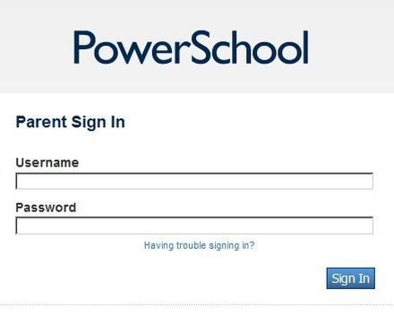
2. On the Recover Account Sign In Information Screen, click on the appropriate
tab and fill in the requested information. For password recovery you will need
to supply your Username (Account Login ID) and a valid email address.
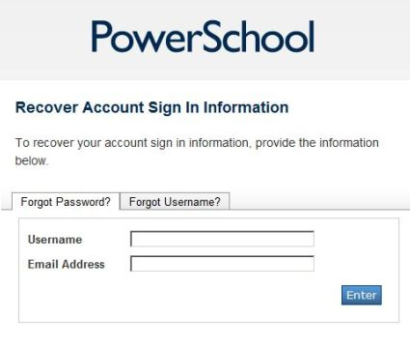
3) For Username (Account Login ID) recovery a valid email address is all that is required:
